**Day trips from Batumi**

***Mtirala National Park Tour***

This tour will give you the most incredible travel experience, guided with the professional and certified tour guide.

We start the tour from Batumi, driving with a 4x4 vehicle. After a few minutes, you will reach one of the most beautiful places in Georgia, Mtirala National Park. Driving through the park with several stops for photo shooting will give you the possibility to enjoy the fresh air and cool weather of ancient subtropic forest. You can also try the best honey from the local farmers.

Soon we start hiking to the Chestnut trail. During the hike, you will see the lake, where you will have a coffee break and you can even swim in the summer. Later we will hike to the beautiful waterfall and return back.

In the end, you can have a delicious lunch from local farmers and enjoy even more outdoor activities like a zip-line and ATV tours.

The Mtirala Mountain is the most humid place in Georgia. This is where its name derives from. Mtirala in Georgian means “crying” or “weeping”. Mtirala National Park has located 30 km from Batumi and shelters various species of fauna and flora of Colchis subtropical forests. The park has two main hiking trails, where you will be amazed by the beauty of the river, waterfalls and lakes.

Start point: Batumi

Tour starts at 10:00 a.m.

Tour duration: 5 hours

Short Itinerary:

* Pick up from the hotel
* National park entrance, photo stop for 5 minutes
* Crossing the extreme footbridge
* The visitors centre, stop for 15 minutes
* Exotic cable car
* Hiking to the lake and waterfall
* Coffee break
* Other activities (not included in the price)
  + Zip-line
  + ATV tour
  + Lunch with organic food from the local farming
* Return to Batumi

Hiking details:

* Trail name: Chestnut forest trail
* Difficulty: easy / moderate
* Distance: 6 km.
* Altitude change: 300 m.

Price list:

|  |  |
| --- | --- |
| **Number of Tourists** | **Price per person in EUR** |
| 2 travellers | 39 EUR |
| 3 travellers | 28 EUR |
| 4 travellers | 20 EUR |
| 5 travellers | 22 EUR |
| 6 travellers | 19 EUR |
| 7 travellers | 18 EUR |
| 8 travellers | 17 EUR |
| 9 travellers | 15 EUR |
| 10 travellers | 13 EUR |

Price includes:

* Comfortable transportation
* Professional guide service
* Coffee, tea and snacks

Other prices

|  |  |
| --- | --- |
| **Activity name** | **Price per person in EUR** |
| Lunch in a local family | 10 EUR |
| Zip-line | 5 EUR |
| Adventure rope park | 10 EUR |
| ATV tour | 35 EUR |

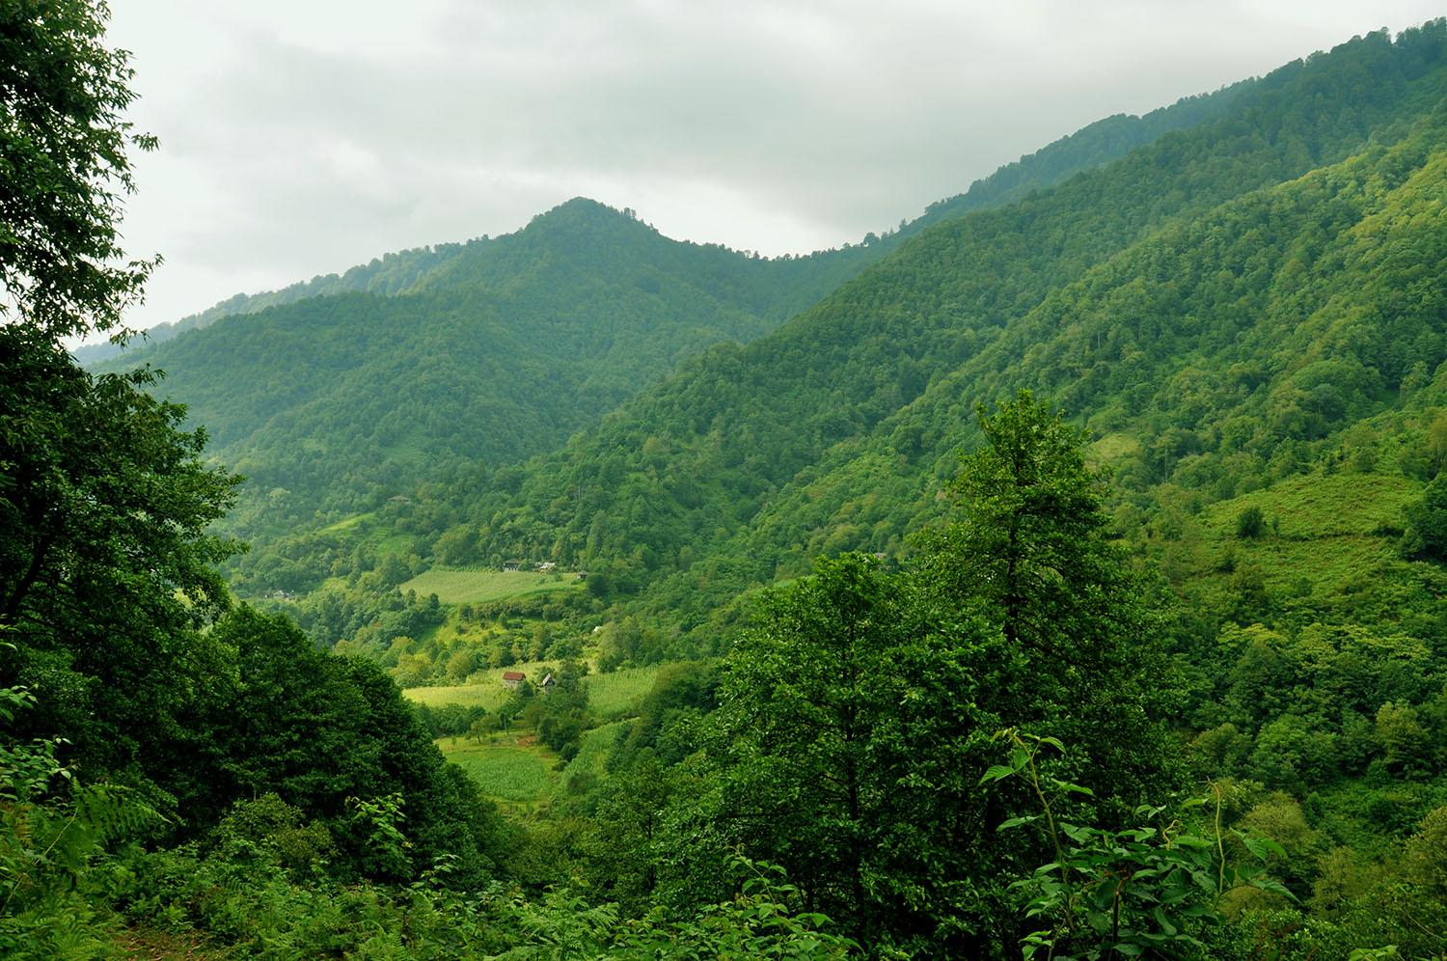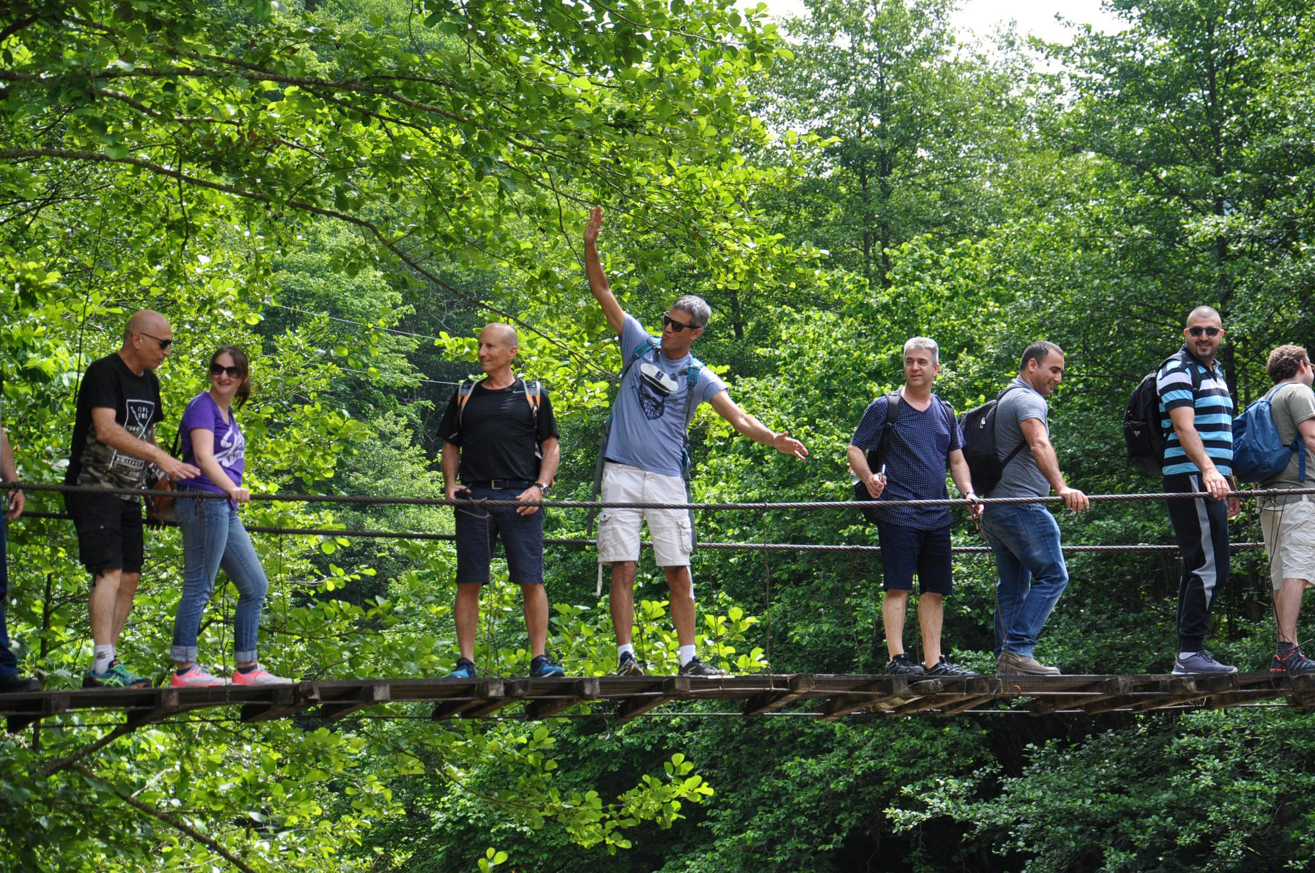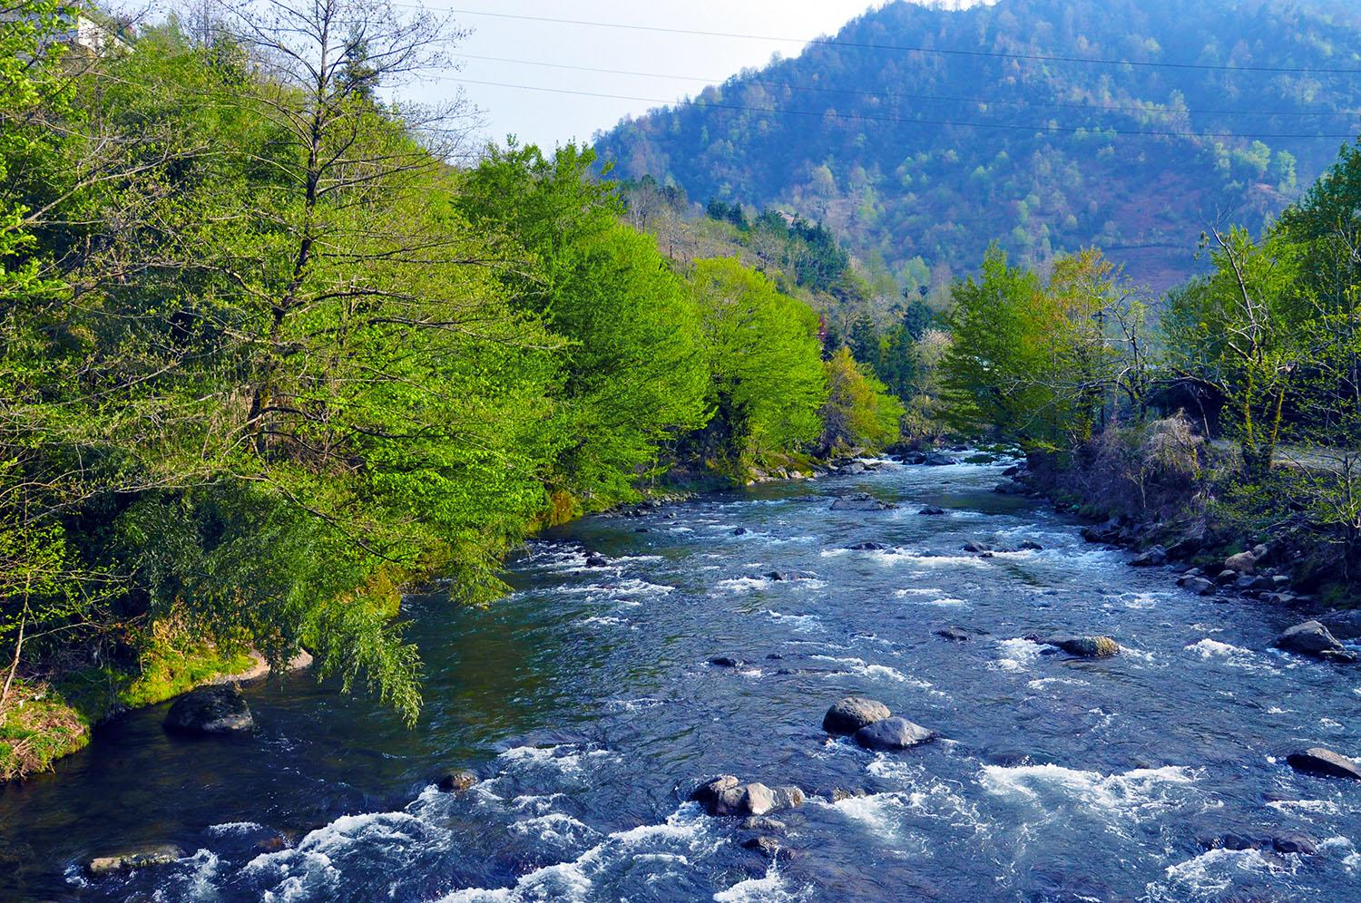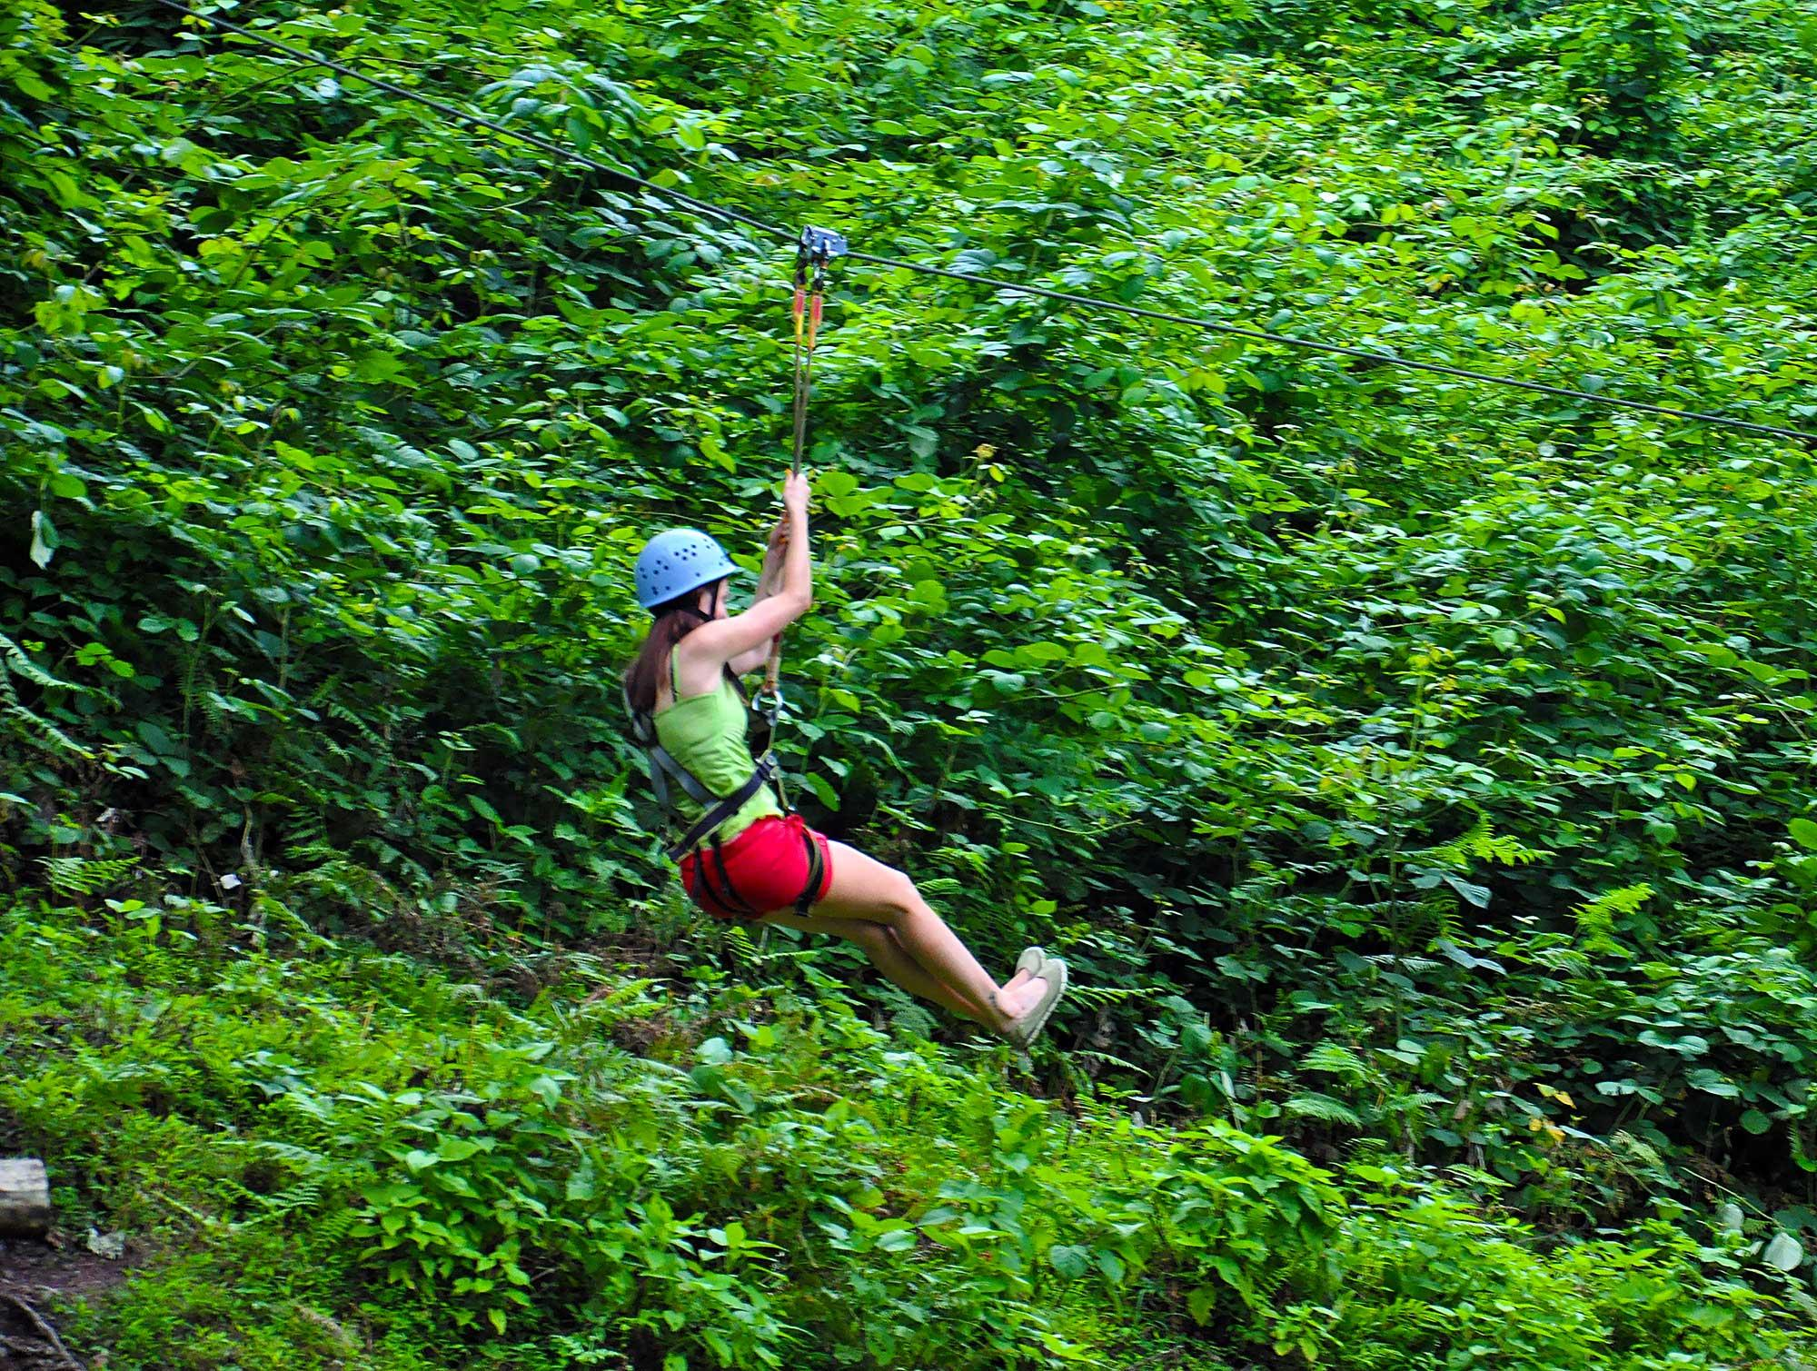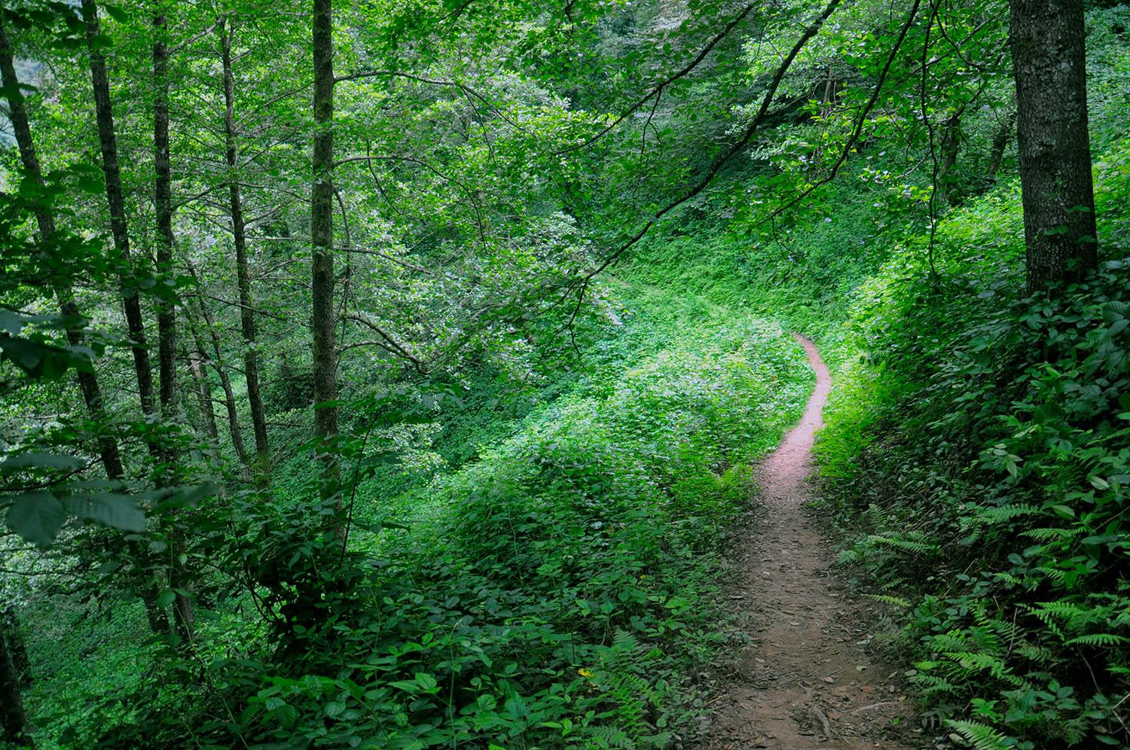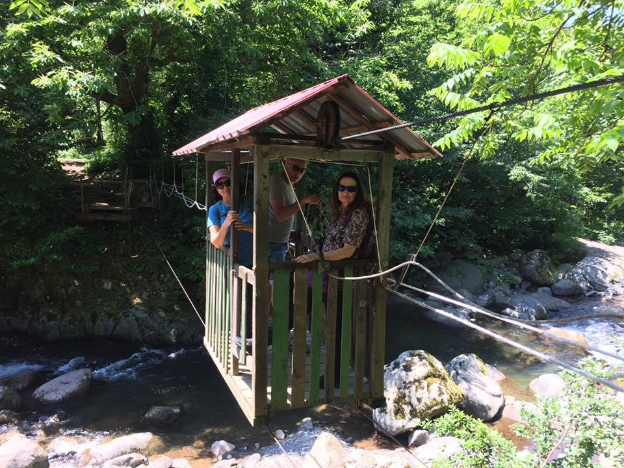

***Mountains and Wine Tour***

Spend a day in the beautiful nature and countryside of Georgia, where you will enjoy the stunning views of rivers and mountains every minute of the trip.

The tour starts from Batumi, Gonio fortress from the first century is the first destination, where you will get familiar with ancient Georgian culture and history, you will continue the trip through the beautiful mountains and valleys with several stops for photography, and later you will see the 50-meter waterfall in the village Makhuntseti.

Besides visiting a beautiful waterfall, you will get familiar with the ancient history of Georgia and the culture of winemaking. The tour will not end without a glass of Georgian wine, drinking in the nice garden of the winery.

Start point: Batumi

Tour starts at 10:00 a.m.

Tour duration: 4 hours

Short itinerary:

* Pick up from the hotel
* Gonio-Apsaros Fortress
* View from the Gonio Mountain
* Makhuntseti Waterfall
* The medieval bridge of queen Tamar
* Georgian Winery, wine tasting
* Return to Batumi

Price list:

|  |  |
| --- | --- |
| **Number of Tourists** | **Price per person in EUR** |
| 2 travellers | 45 EUR |
| 3 travellers | 33 EUR |
| 4 travellers | 27 EUR |
| 5 travellers | 25 EUR |
| 6 travellers | 22 EUR |
| 7 travellers | 20 EUR |
| 8 travellers | 19 EUR |
| 9 travellers | 18 EUR |
| 10 travellers | 17 EUR |

Price includes:

* Comfortable transportation
* Professional guide service
* Entrance ticket in Gonio fortress
* Entrance ticket in the winery
* Wine tasting

Other prices

|  |  |
| --- | --- |
| **Activity name** | **Price per person in EUR** |
| Lunch in the Georgian winery | 12 EUR |

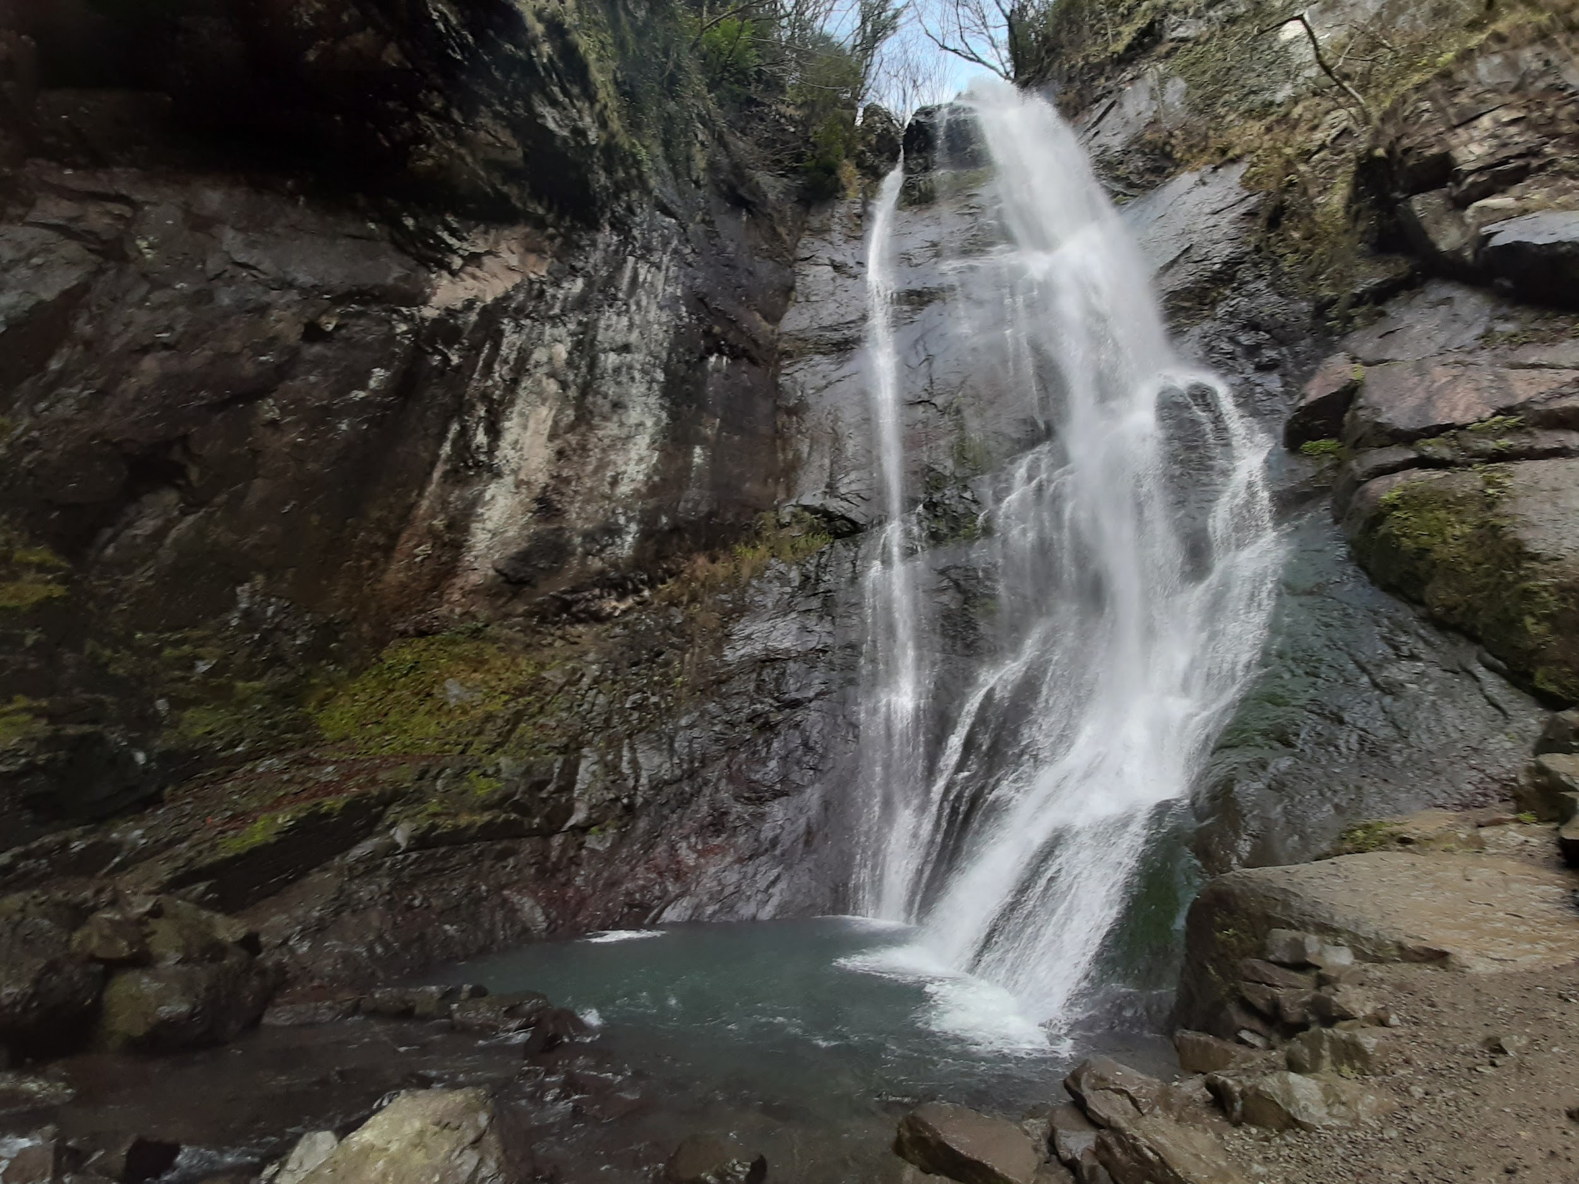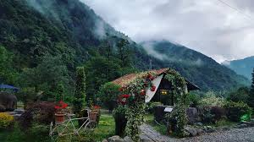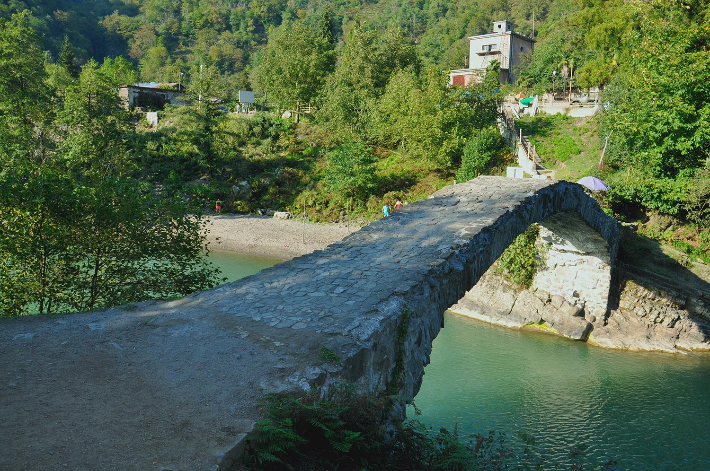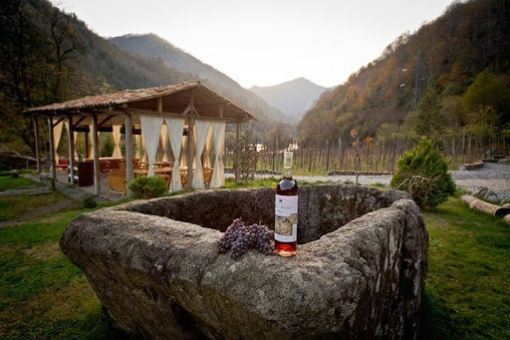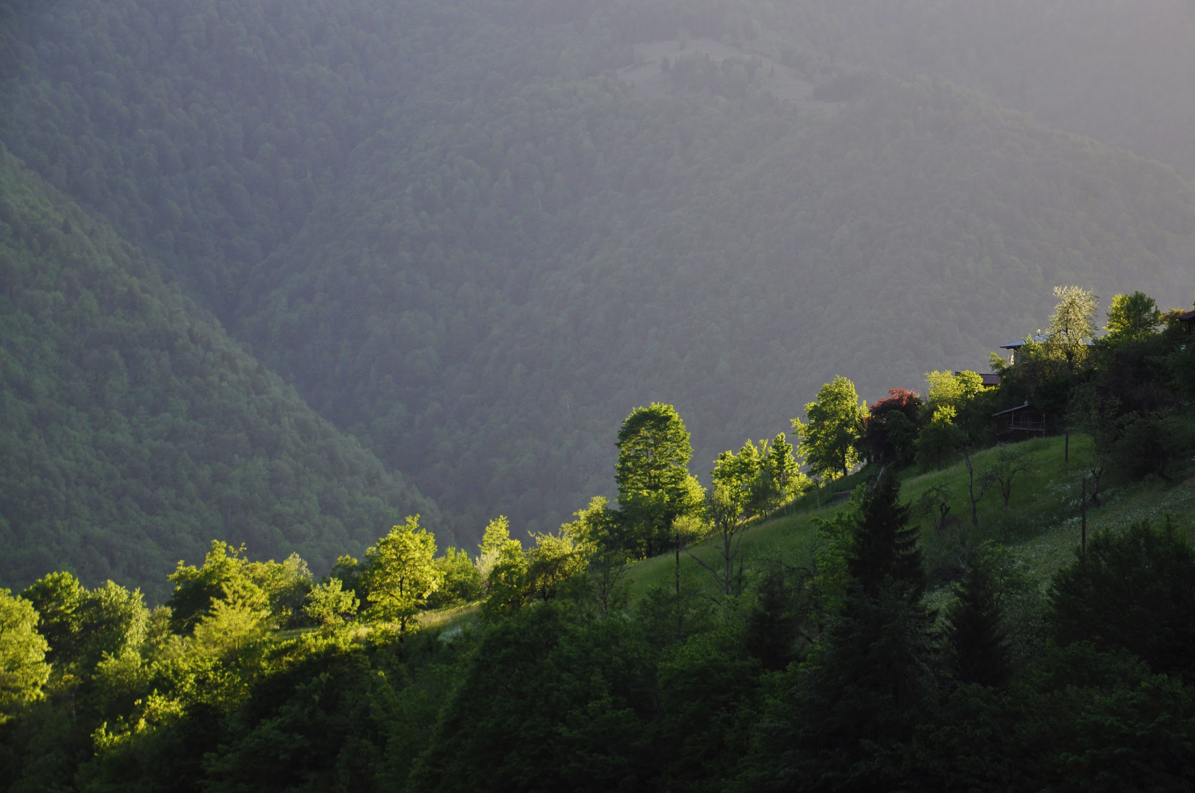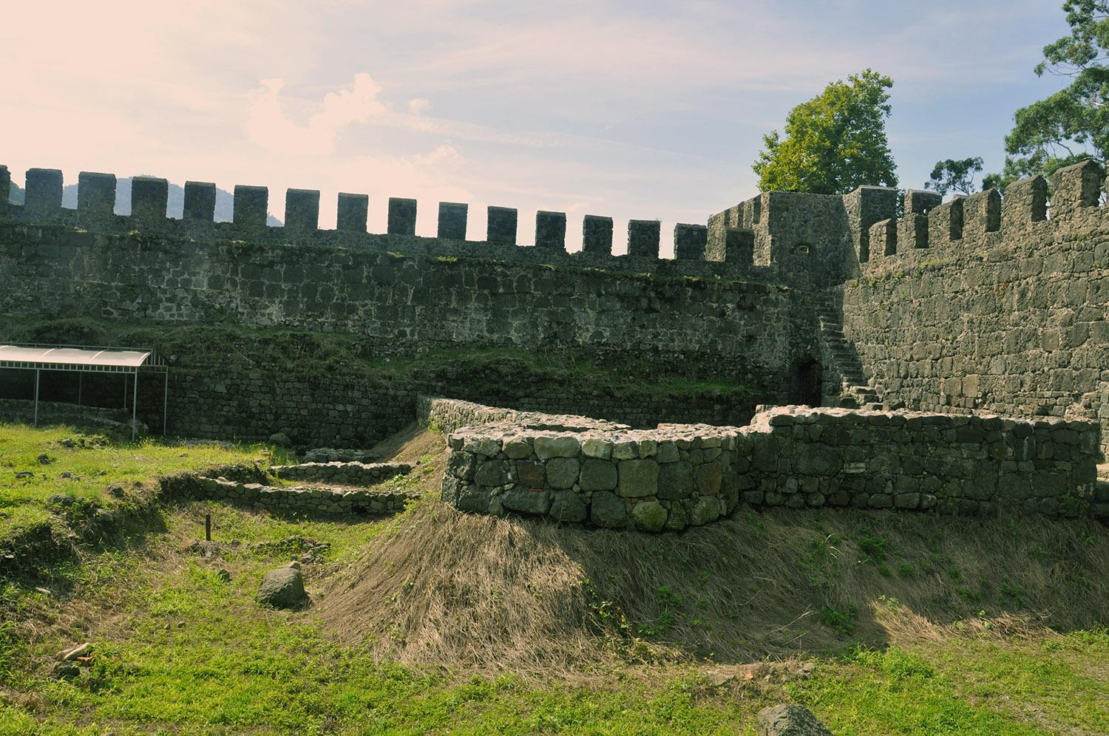

***Machakhela Folk Tour***

Machakhela valley is the protected area near Batumi, with its waterfalls, rivers, stunning landscapes and local villages it is the best place to enjoy a day outside Batumi. In this tour, there is combined nature and culture together,

The tour starts with driving from Batumi to the village Mirveti, on the way you will see the beautiful view of two rivers confluence and will have stop for photo shooting. Mirveti is a nice village where you can get familiar with local village life, try local honey and fruits, also have a look at the Queen Tamar medieval bridge. This village is famous for the most beautiful waterfall in Adjara.

After taking the pictures at the waterfall of Mirveti, you will continue driving to Machakhela valley, You will visit Machakhela gun monument, before passing authentic villages of Machakhela valley, after seeing another medieval bridge you will have a stop in the local villager’s family, where you will get familiar with the tradition of Georgian supra and having delicious lunch with Georgian wine and chacha. The family folk show during supra will give you even more emotions and unforgettable memories. Masterclass in Georgian dances and toasts will make you feel like real Georgian.

Start point: Batumi

Tour starts at 10:00 am.

Tour duration: 7 hours

Schedule:

* Chorokhi and Acharistskhali river confluence
* Mirveti Waterfall
* Medieval bridge of Mirveti
* Machakhela rifle monument
* Medieval Bridge of Tskhemlara
* Waterfall of Kvemo Chkhutuneti
* Local village family
  + Georgian supra (dinner with traditional Georgian toasts)
  + Georgian folk show
* Return to Batumi

Price list:

|  |  |
| --- | --- |
| **Number of Tourists** | **Price per person in EUR** |
| 2 travellers | 50 EUR |
| 3 travellers | 38 EUR |
| 4 travellers | 30 EUR |
| 5 travellers | 27 EUR |
| 6 travellers | 25 EUR |
| 7 travellers | 23 EUR |
| 8 travellers | 22 EUR |
| 9 travellers | 20 EUR |
| 10 travellers | 19 EUR |

Price includes:

* Comfortable transportation
* Professional guide service
* Traditional Supra-dinner in Georgian village family
* Georgian folk show

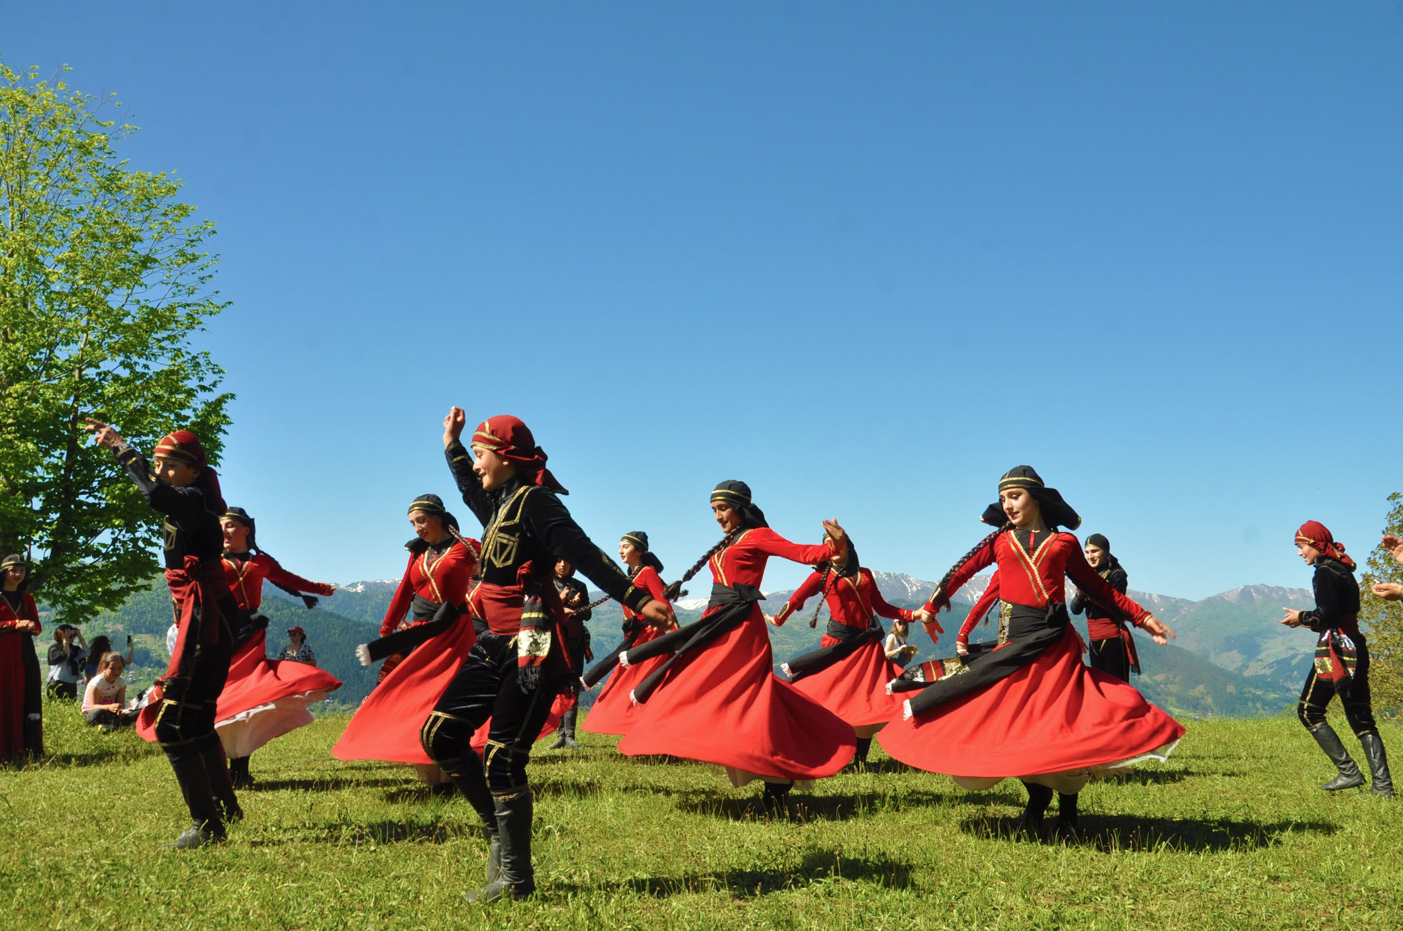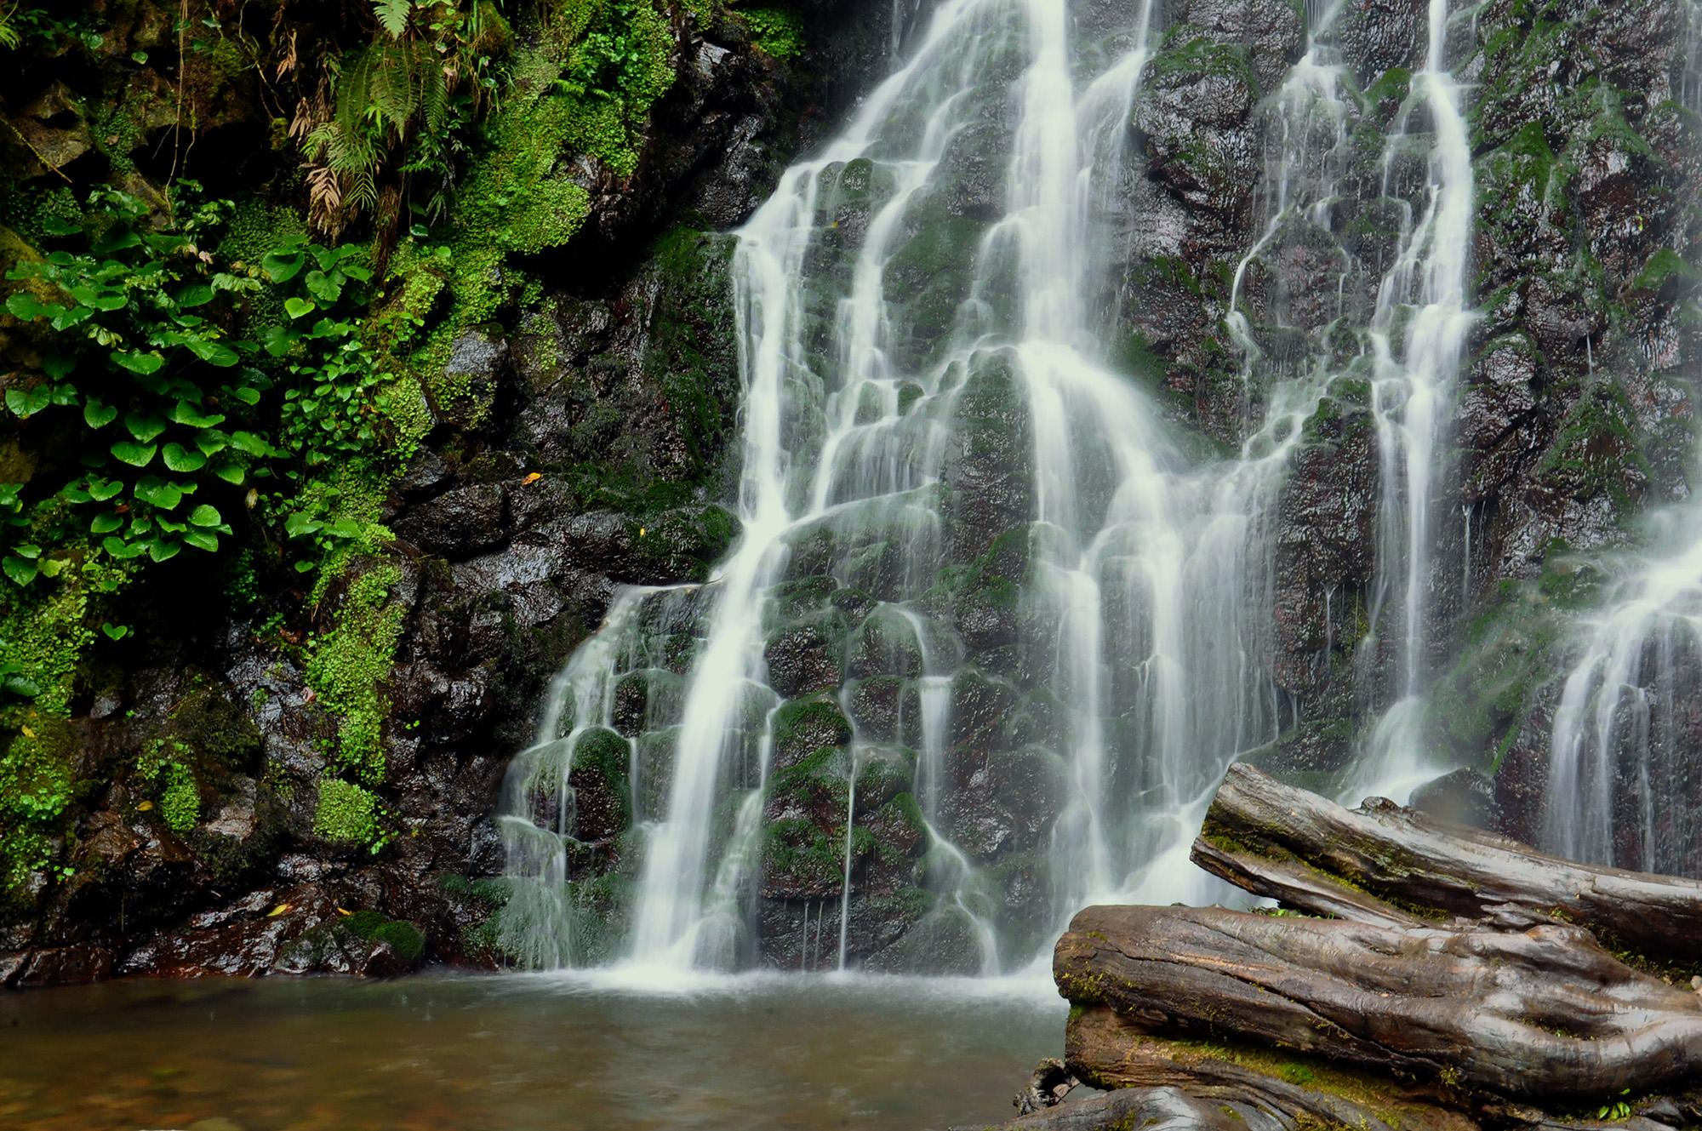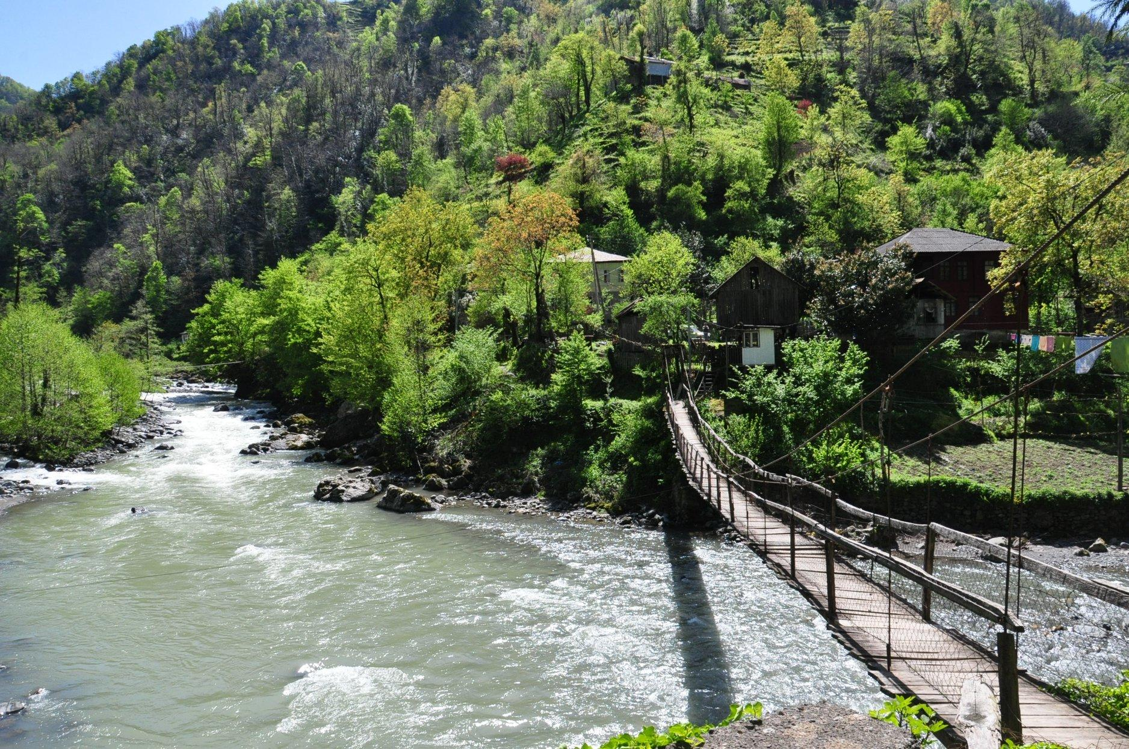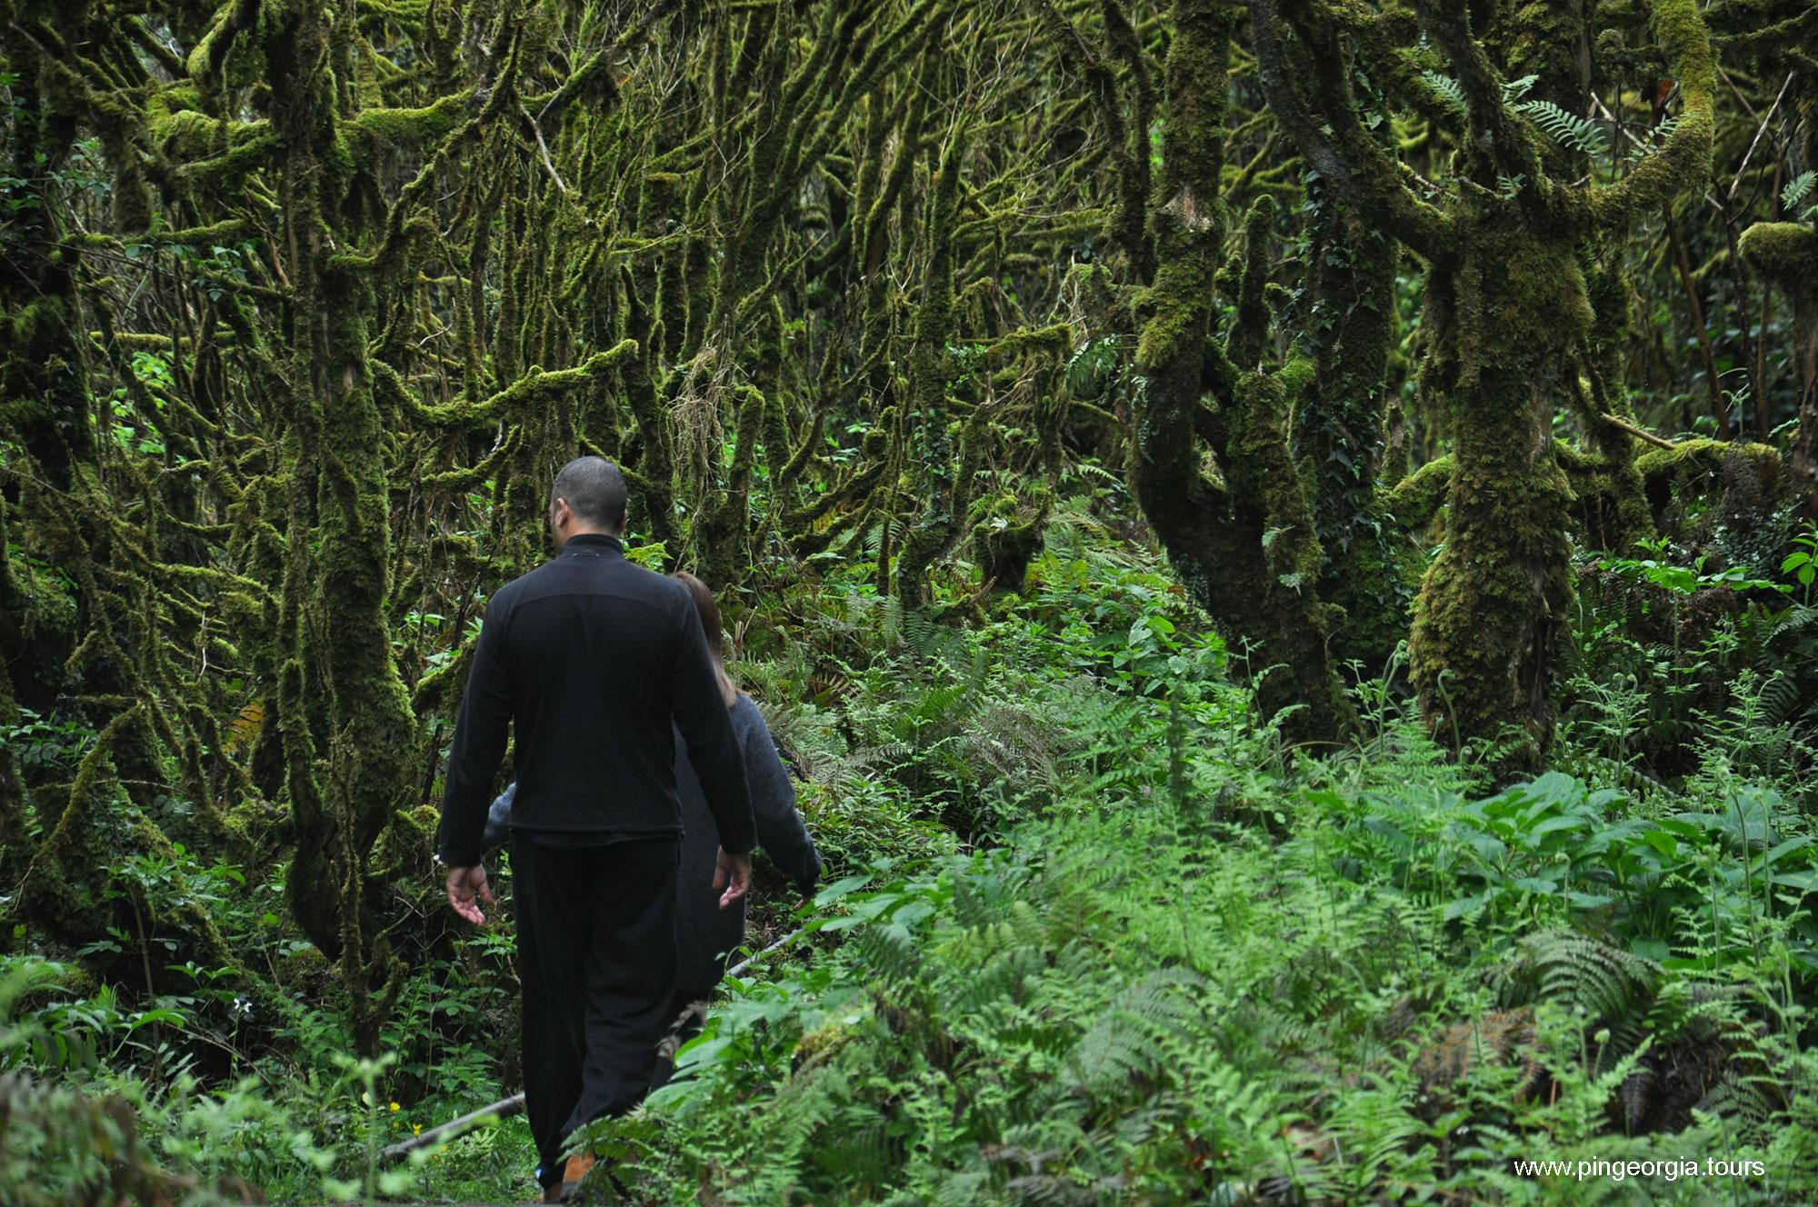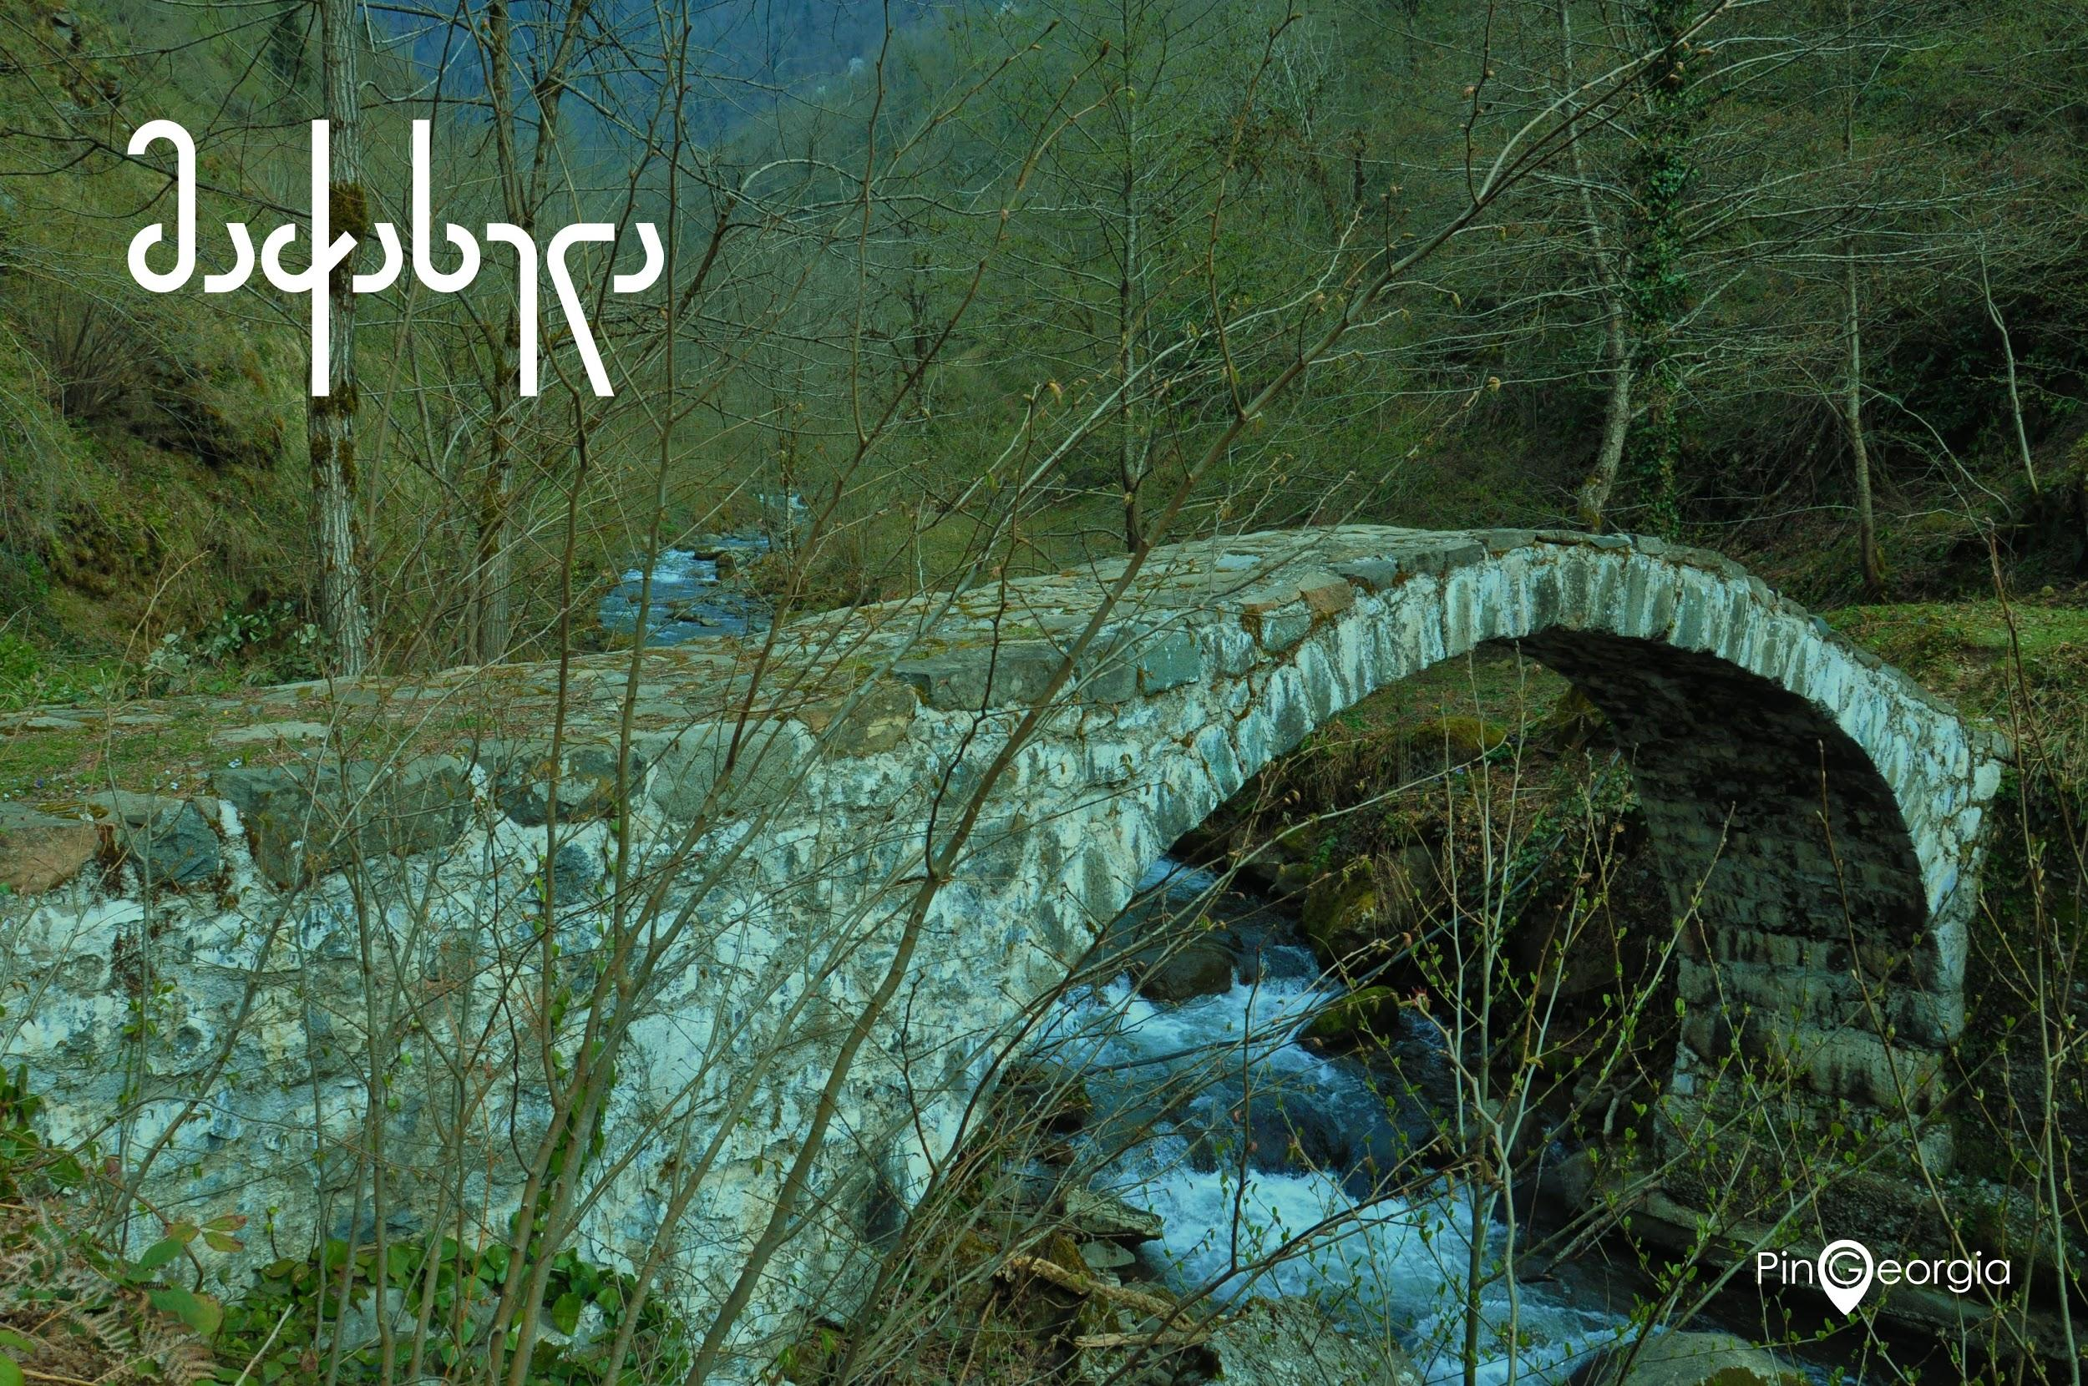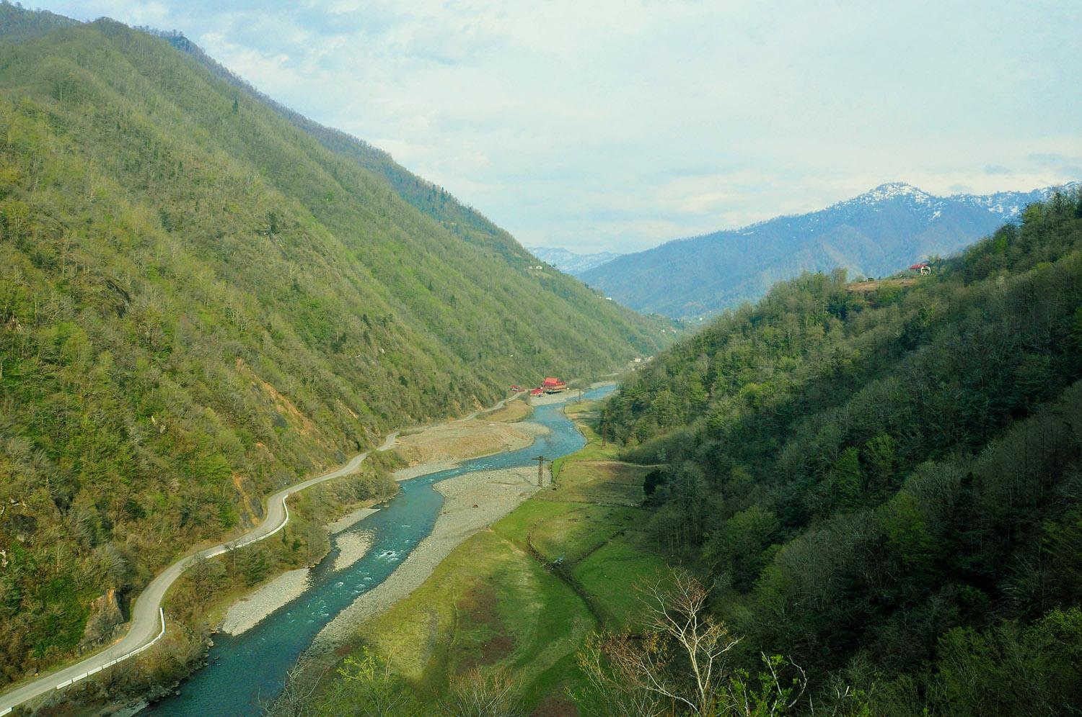

***Walking Tour in Batumi***

Batumi, also known as the pearl of the Black Sea is not only famous for its beautiful parks and attractions, but it has a very unique history since once it was the most famous and modern city in Europe.

With its mixture of historical and modern architecture, the walking tour around Batumi will give you the most interesting travel experience.

Tour duration: 3 hours

Price list:

|  |  |
| --- | --- |
| **Number of Tourists** | **Price per person in EUR** |
| 2 travellers | 22 EUR |
| 3 travellers | 15 EUR |
| 4 travellers | 11 EUR |
| 5 travellers | 9 EUR |
| 6 travellers | 8 EUR |
| 7 travellers | 7 EUR |
| 8 travellers | 6 EUR |
| 9 travellers | 5 EUR |
| 10 travellers | 4 EUR |

Price includes:

* Professional guide service

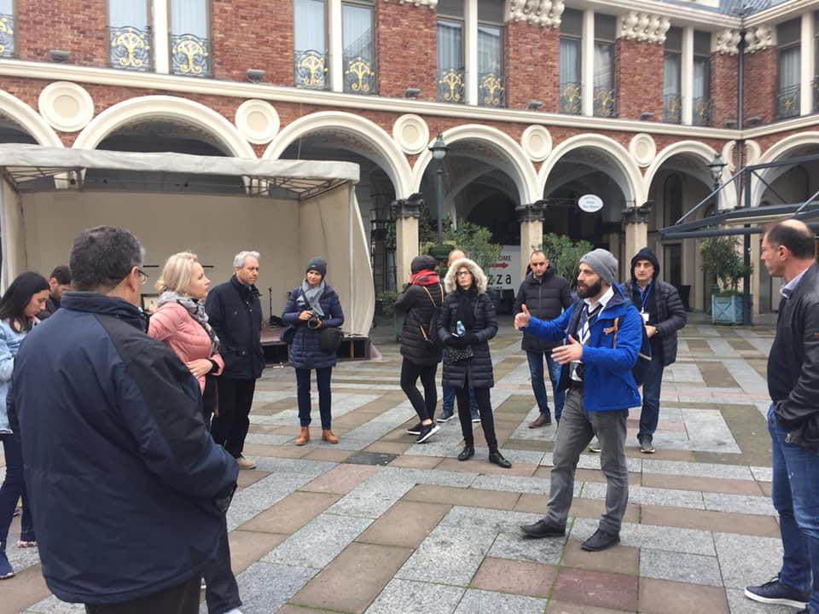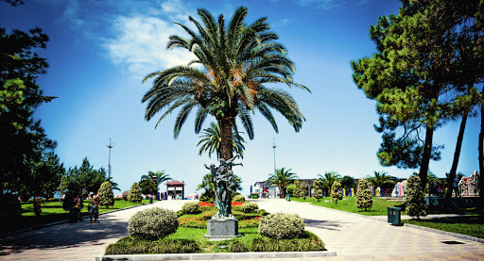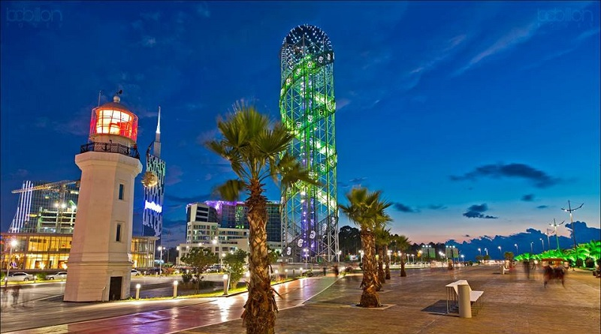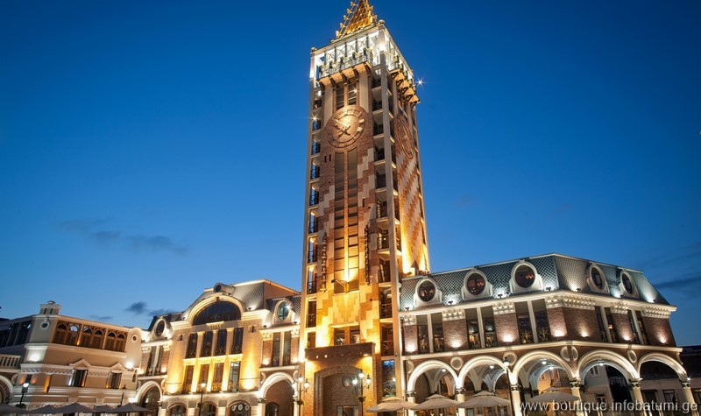

***Batumi Botanical Garden Tour***

The Botanical Garden of Batumi has a special subtropic climate, where various plants are grown. The mixture of the subtropic plants, mountains and the sea creates special and stunning views while walking in the beautiful garden.

Batumi Botanical Garden is the best place to spend an hour or two near Batumi. The tour includes driving from Batumi centre to the botanical garden and of course interesting and professional guide, who will make your walk, even nicer and interesting. In the garden, it is possible to have a ride by an electric trolley.

Tour duration: 3-4 hours

Price list:

|  |  |
| --- | --- |
| **Number of Tourists** | **Price per person in EUR** |
| 2 travellers | 32 EUR |
| 3 travellers | 25 EUR |
| 4 travellers | 20 EUR |
| 5 travellers | 18 EUR |
| 6 travellers | 16 EUR |
| 7 travellers | 14 EUR |
| 8 travellers | 13 EUR |
| 9 travellers | 12 EUR |
| 10 travellers | 11 EUR |

Tour includes:

* Comfortable transportation
* Professional guide service
* Entrance tickets

